RECIPE
Lemon Baked Chicken with Garlic Cream Sauce
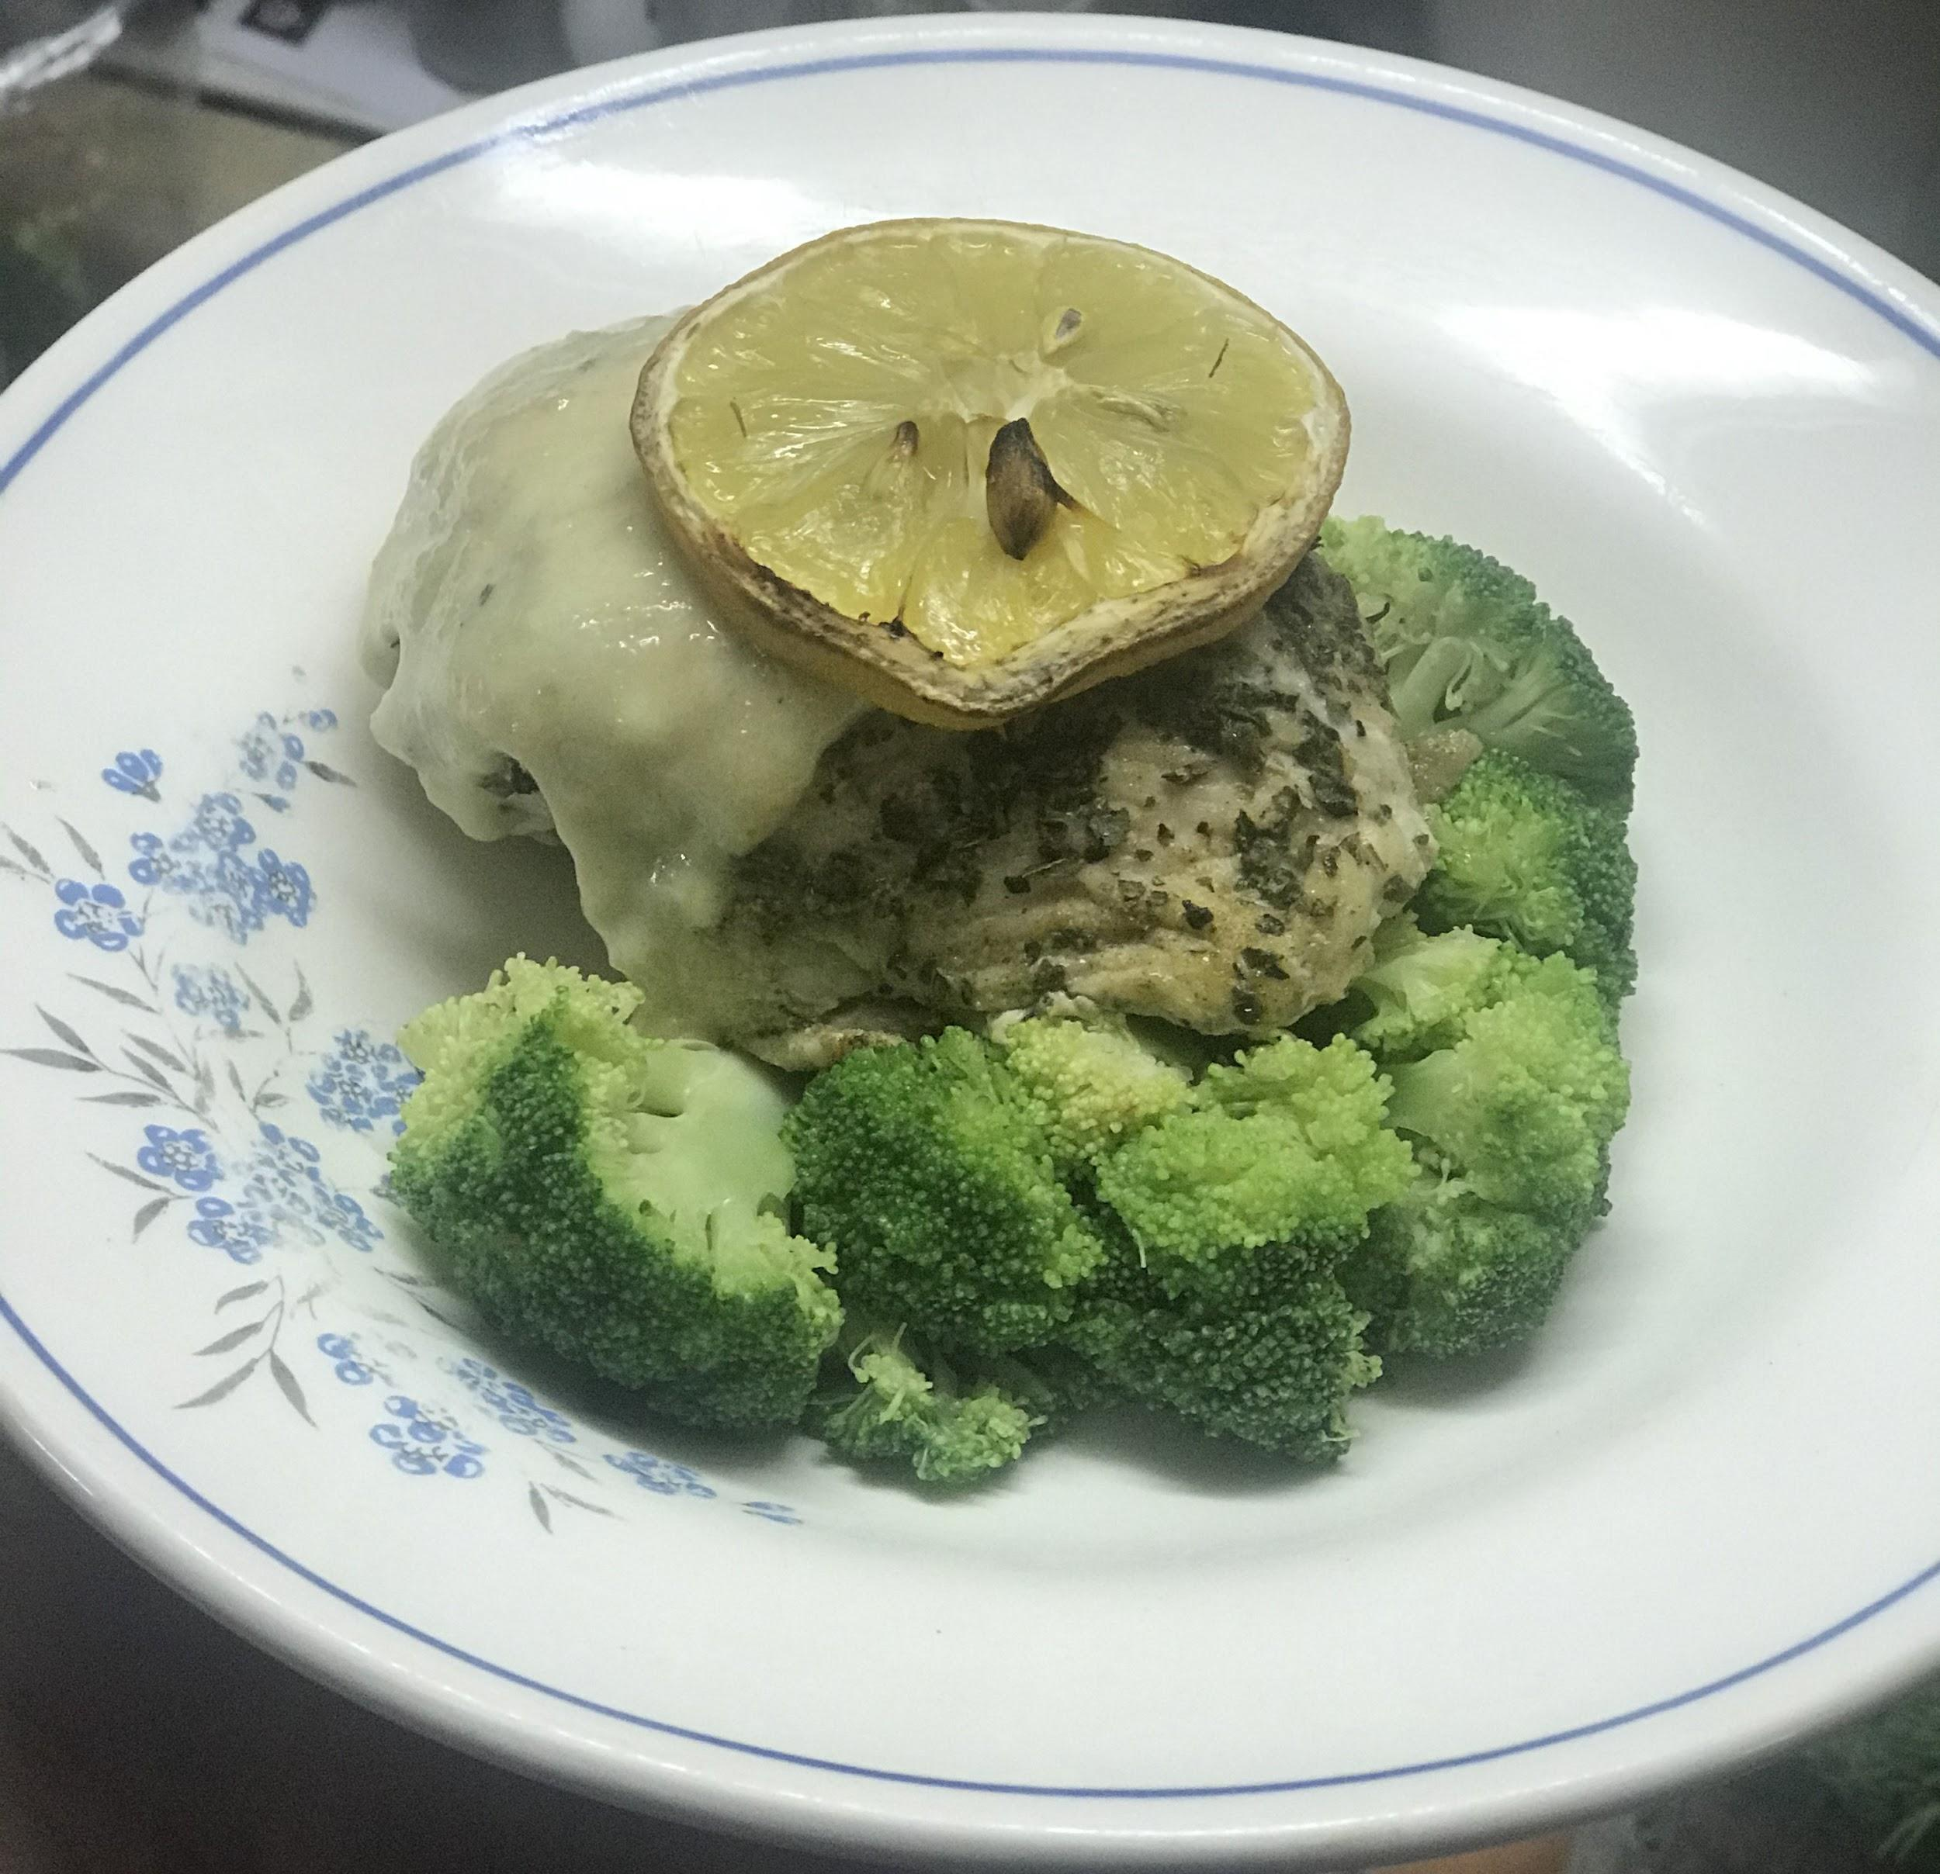
Ready in less than 30 minutes
Serves 1 serving

Ingredients
- Basil Ginger seasoning (Enough to cover the chicken)
- 1 chicken breast
- 2 slices of lemon
- Heavy Cream (1 cup)
- Garlic Minced (2 tbsp)
- Grated Parmesan (3 tbsp)
- Steamed Broccoli 1 cup

Preparation
- Preheat your oven to 400℉
- Season your chicken breast
Cover the chicken breast with Flavor Imperium’s Basil Ginger Seasoning. Place on your nonstick baking sheet or prep it for baking by spraying the baking sheet Before putting it into the oven. Put one of your slices of lemon on top of the chicken. Then put your chicken into your preheated oven to bake for 14-20 minutes. Five minutes before its done pull out the chicken, squeeze the second slice of lemon on top of your chicken, and put back in the oven.
- Put your garlic into a saucepan and saute it until aromatic. Then pour your heavy cream into your pan and also add your parmesan. Cook your sauce on medium and let it simmer down. Continually taste your sauce and tweak it according to your taste.
- In a pot of boiling water, submerge your broccoli. I like mine to have a bit of a crunch, so I steam it until its fork-tender. Once it is done, pull it out of the water.
- Plate your dinner! Put the broccoli on the plate first, then lay your chicken on it., and put your sauce on top of your chicken and finish with a slice of lemon.

